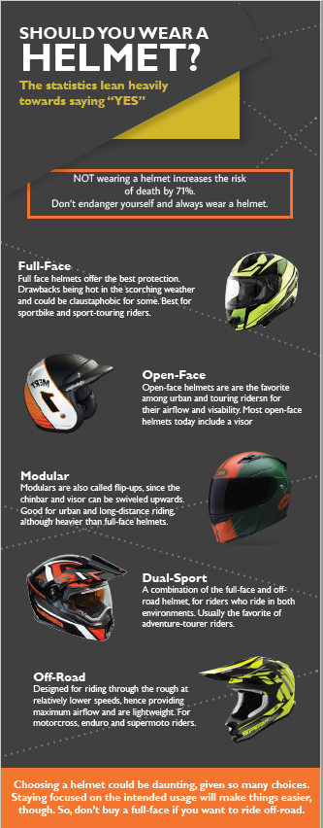
You will be graded on your ability to create this document “exactly” including proportions of the individual helmet pictures, and how they fall on the page.

You can create a “template layer” and place an image of the infographic on it so that your objects can match.

Document Setup:

- Dimensions: 7 in x 18 in
- Make sure you turn off “hyphenate” in the paragraph options

Font Family: Gill Sans
Color Hex Codes
Very Dark Grey: #414042
Dotted Lines: # 77787b
Yellow: #d3b62a
Orange: #f4762e
Title Section
1st line: 26pt bold
Second line: 64pt bold
Yellow text: 20pt bold

Orange Box + text:
- 18pt, Centered (no bold)
- Hit enter before “of” to push to new line
*Watch punctuation! Also, make sure the text is centered in the box. Look for options in Character and Paragraph Panels!

Formatting Paragraphs
Titles:20pt Bold
Text: _{14pt}

Bottom text
Center, 20 pt bold

Notes:
- Top two graphics have shadows on them.
- Watch your layers. You will need to group your objects according to the stacking order

